# ***How to deploy static web app on ec2 instance***

* Firstly, we need to launch one ec2 instance below are the steps 👇
* Loign to aws account and go to ec2 service dashboard

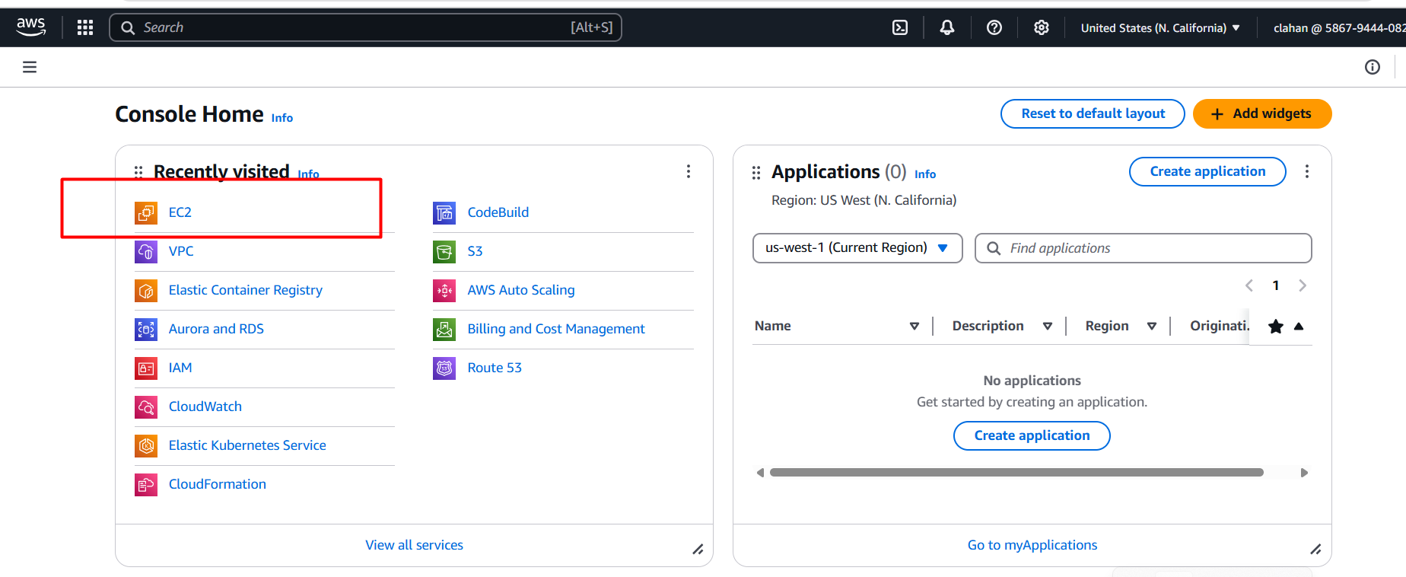

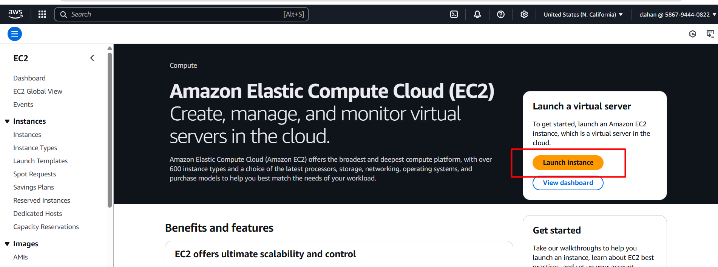

* Give a name for your ec2 instance as below image

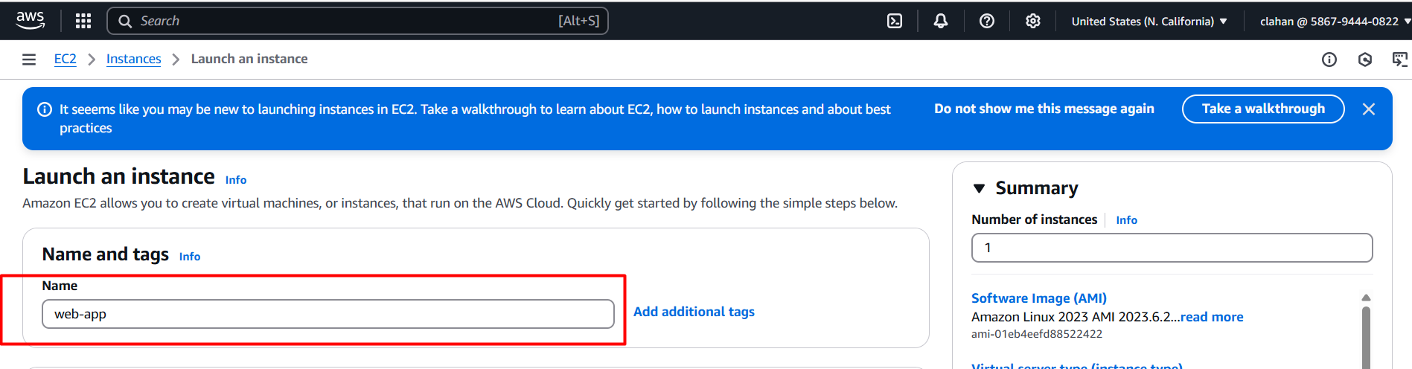

* Choose operating system ubuntu (in this case I am choosing ubuntu based on your requitement you can change the OS)

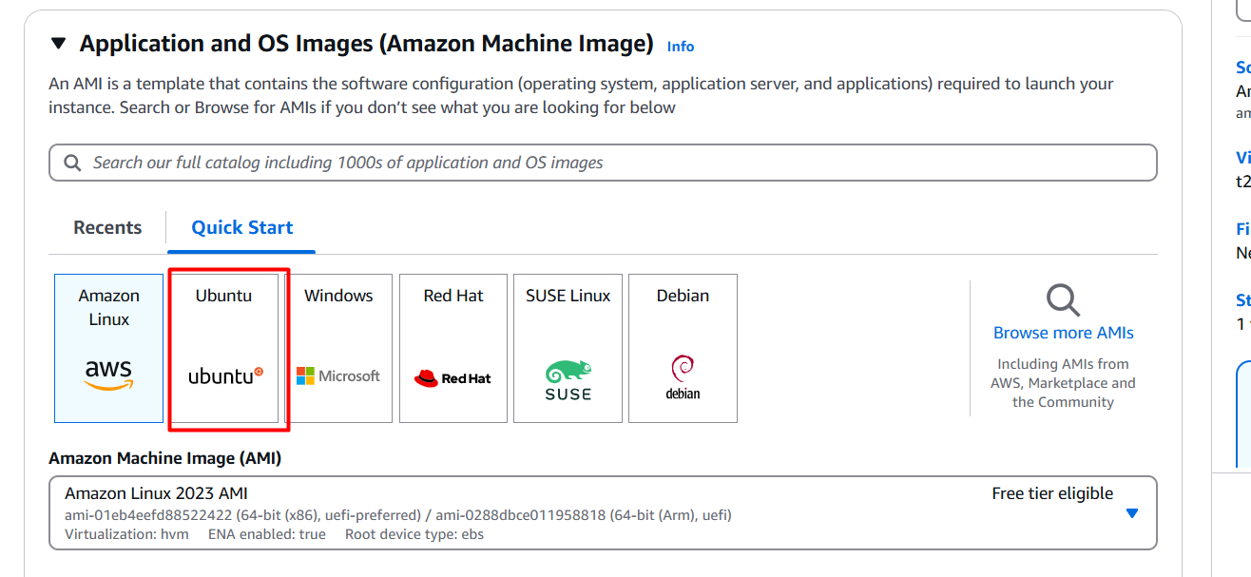

* Next choose instance type here I am choosing t2.small for deploying simple static web app (but based on app requirement instance type will be changed)

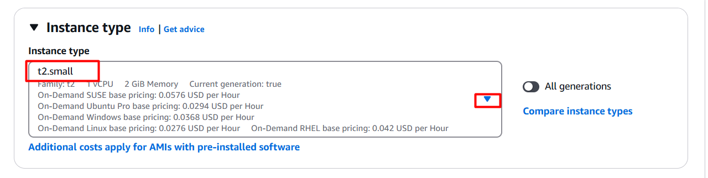

* Next, we need to key pair for connecting ec2 instance.
* How to create key pair follow below steps 👇
* Click on create new key pair

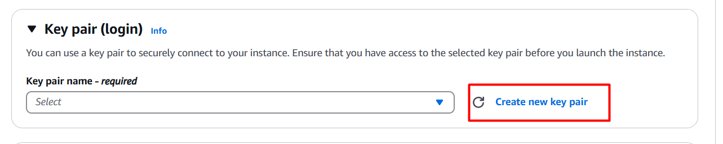

* Provide a name for key pair, select RSA, choose .ppk and click on create key pair 👇

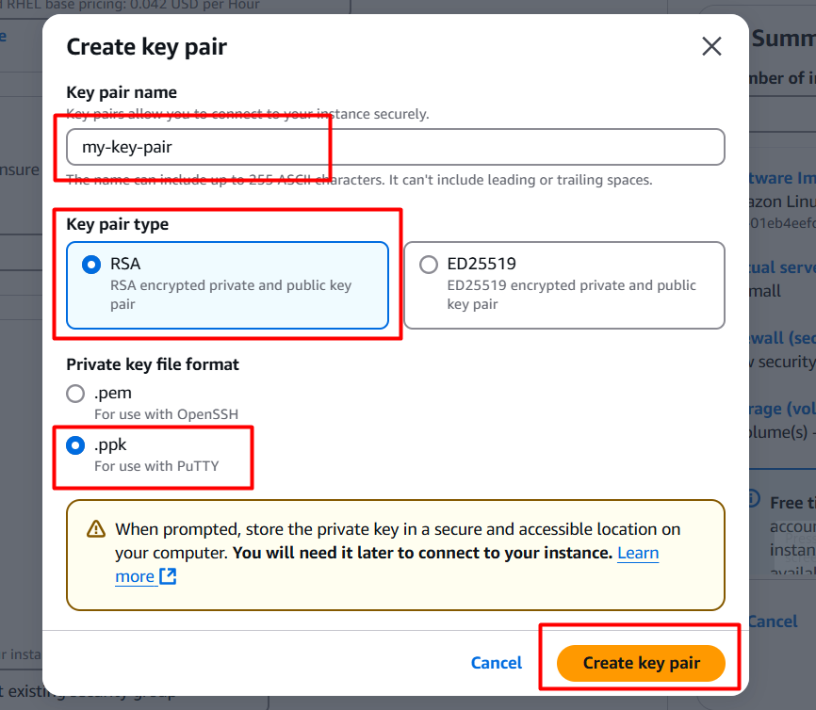

* It will be downloaded into your local server and go to file manager 🡪 downloads there you can see your new downloaded key pair

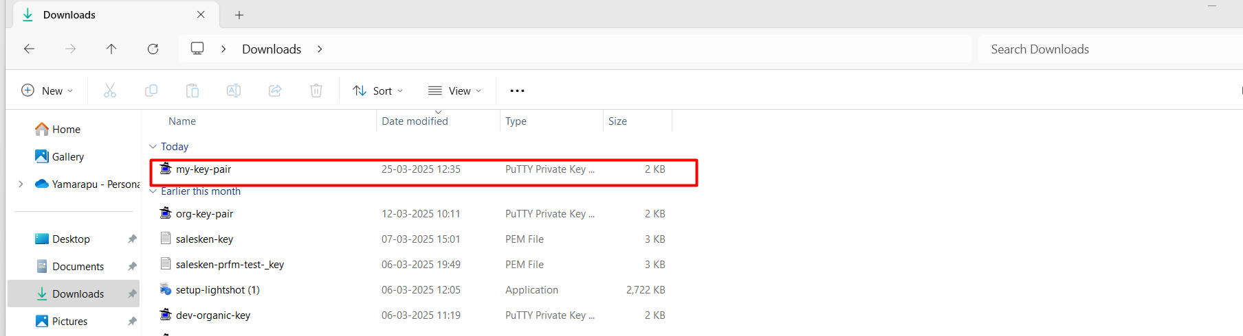

* Next in networking section we need to create one security group for enable port numbers 👇

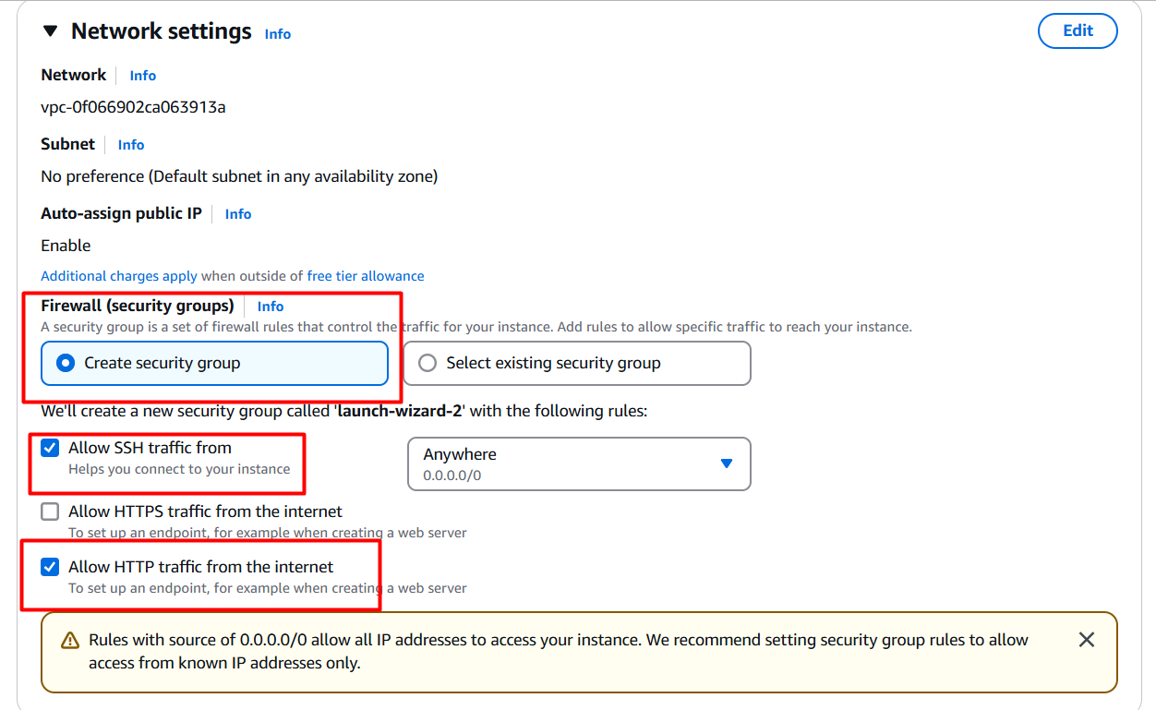

* Next we need to configure storage based upon app requirement , here I am choosing 15gb for static web app 👇

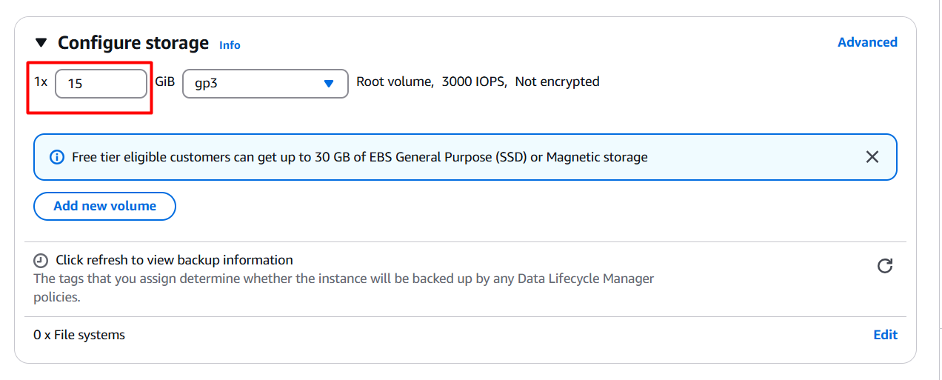

* Finally, we need to launch the ec2 instance 👇

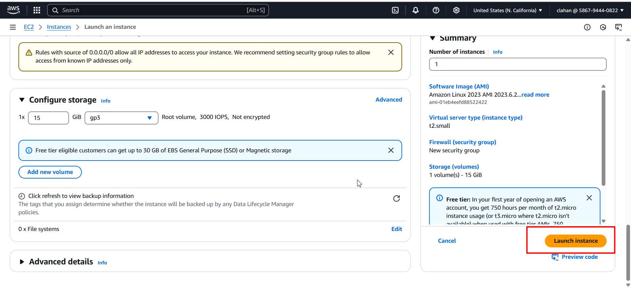

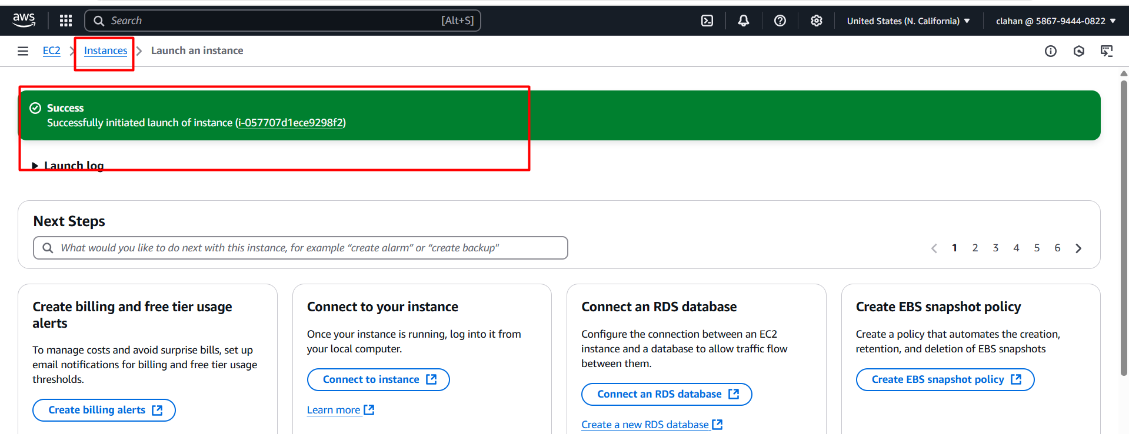

* Click on instances you can see your new created instance ☝️

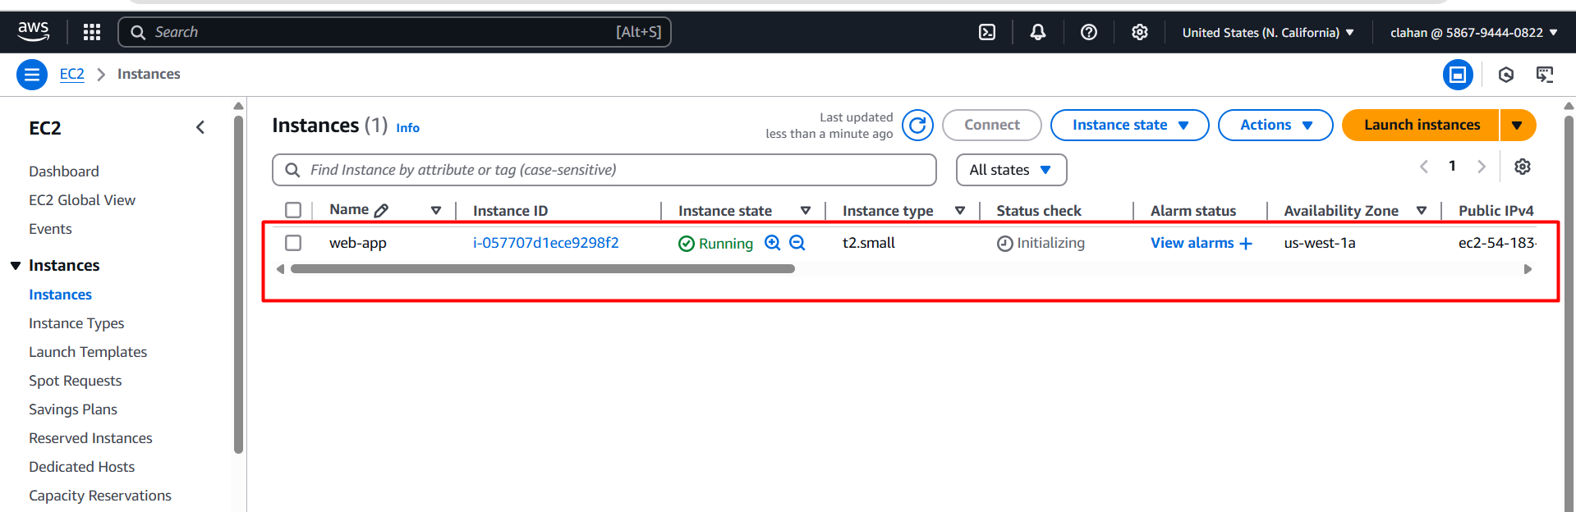

* Now we need to connect our ec2 instance for we have to install putty software on your local servers
* Go to google search putty download on windows 👇

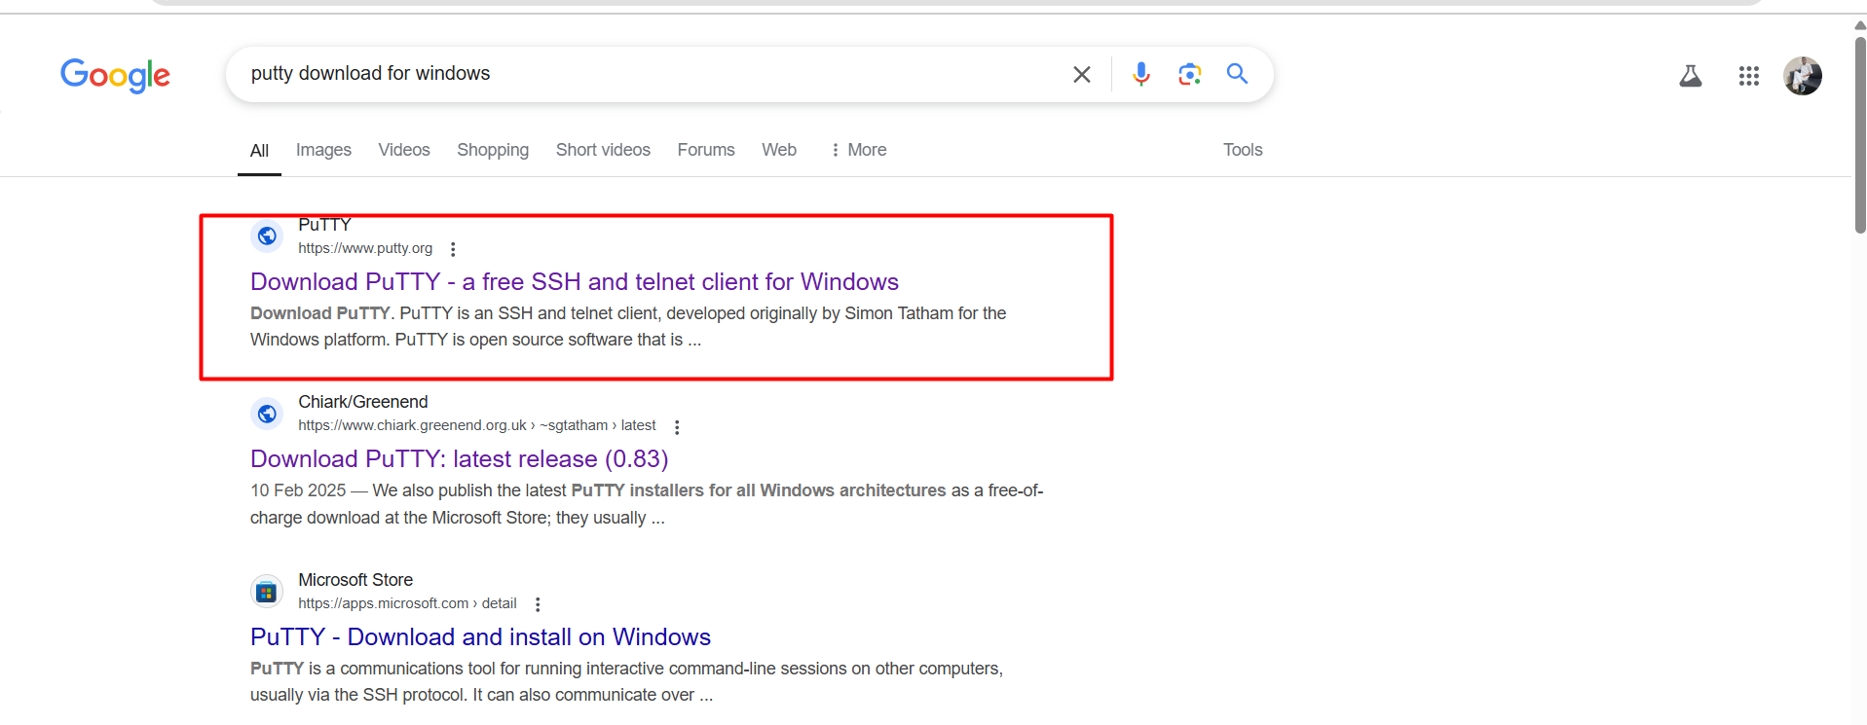

* Click on download option

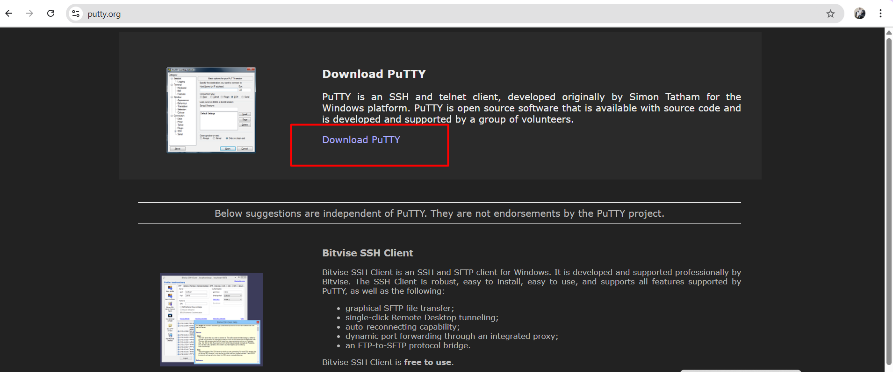

* It will download into your local server
* Then open putty server on your local machine 👇

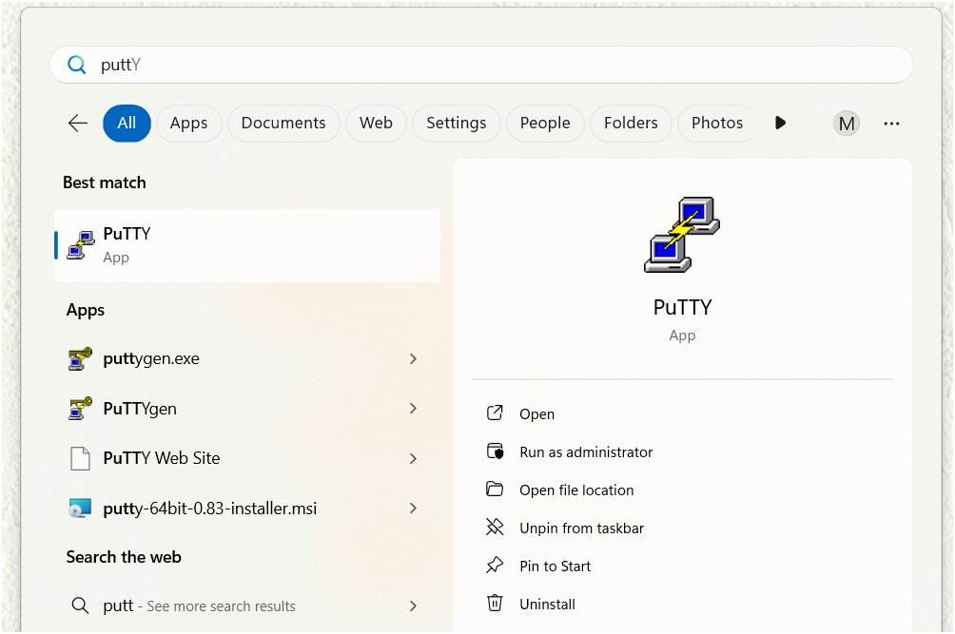

* It will open like this 👇

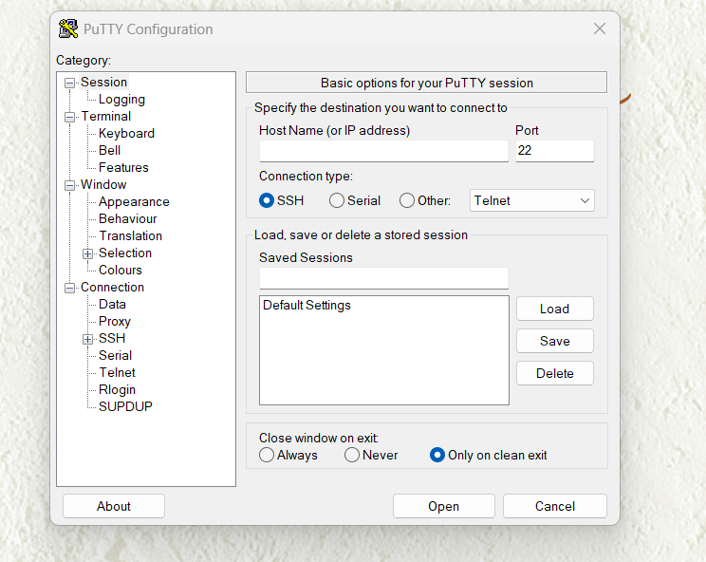

* Now go to your aws console and go to ec2 instance 👇



* Choose your instance and click on connect

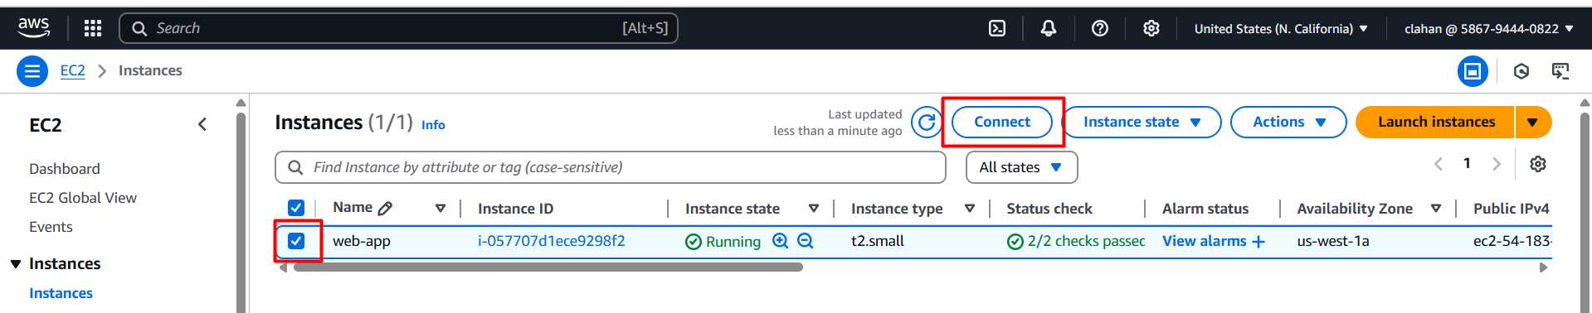

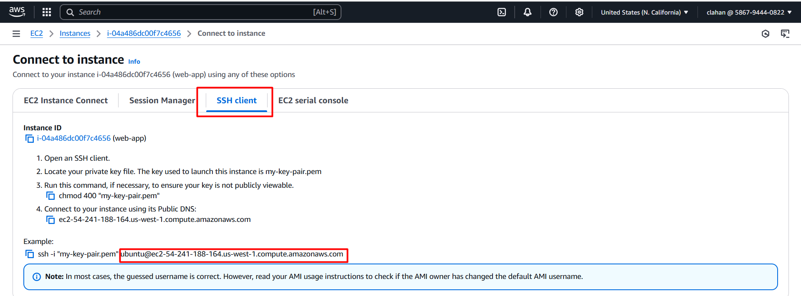

* Go to putty server enter copied host name as mentioned above image (second marked box)

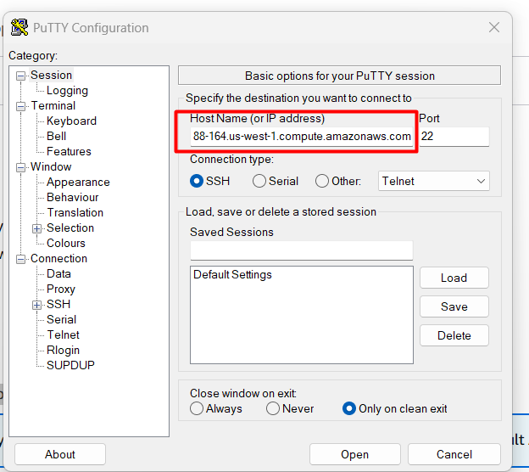

* Click on appearance and change for changing font size

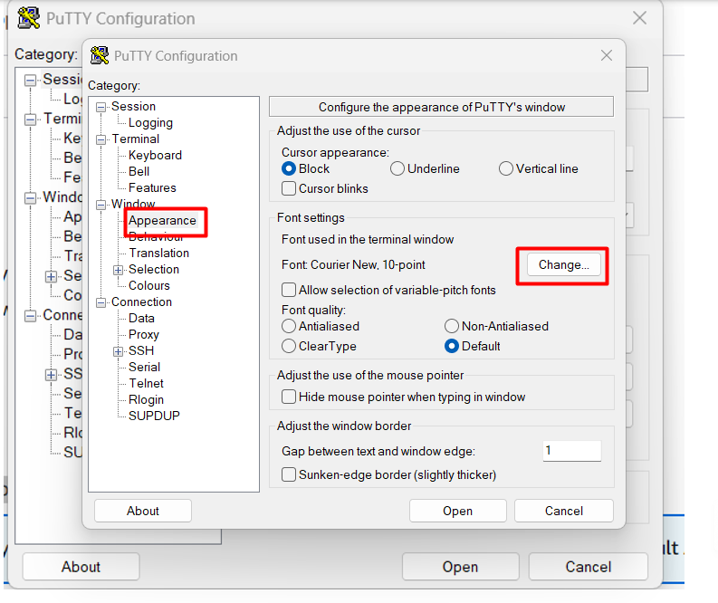

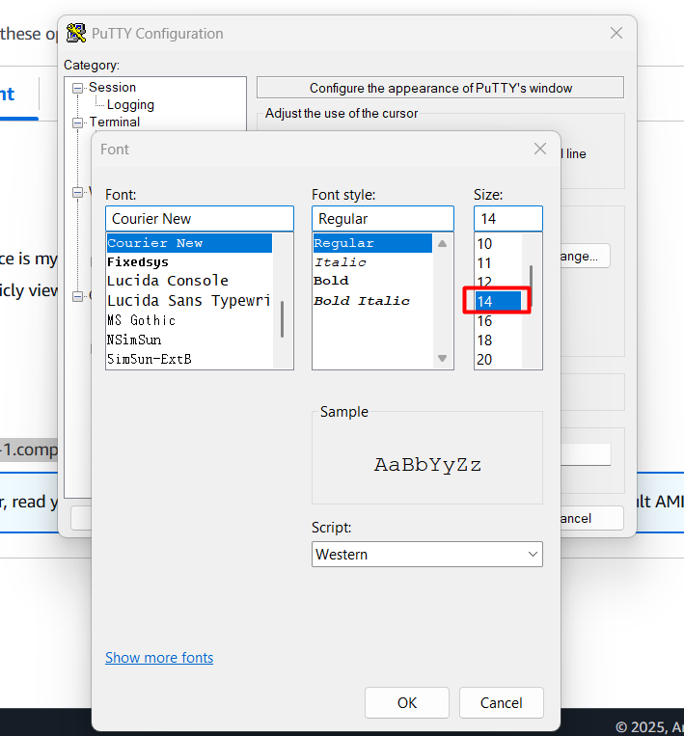

* Next click on connection and give 60 sec for timed out

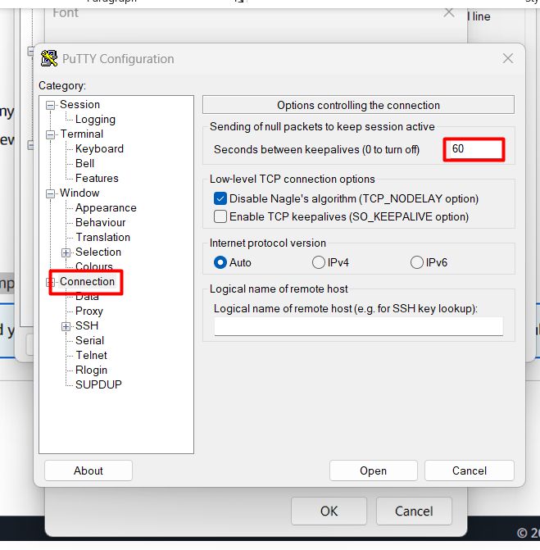

* Click on ssh 🡪 auth 🡪 credentials 🡪 browse

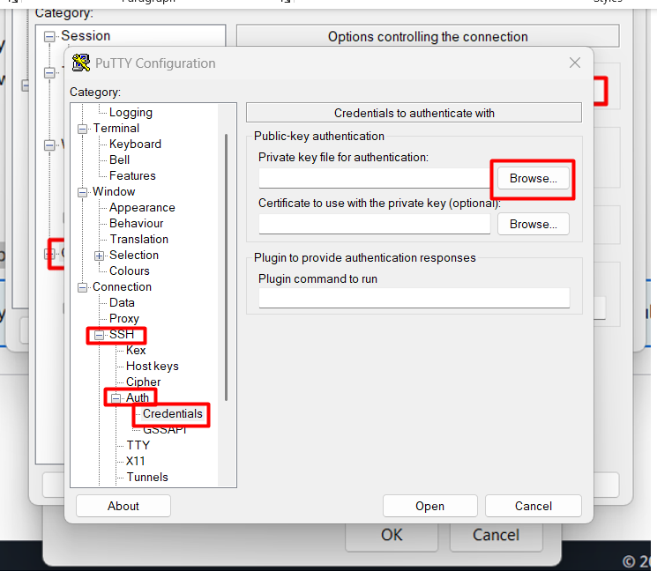

* After it will redirect into your file manager there choose your downloaded key pair

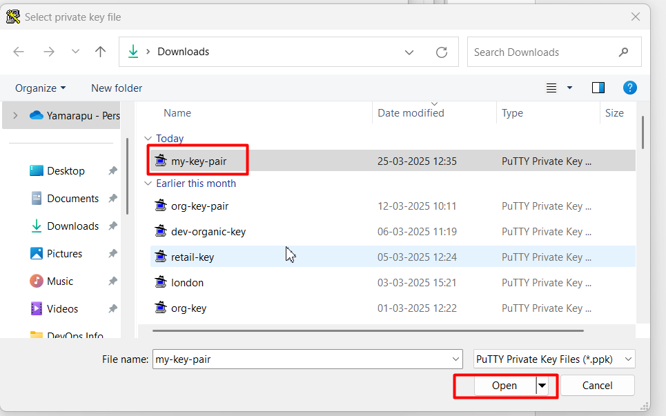

* Next again click on open

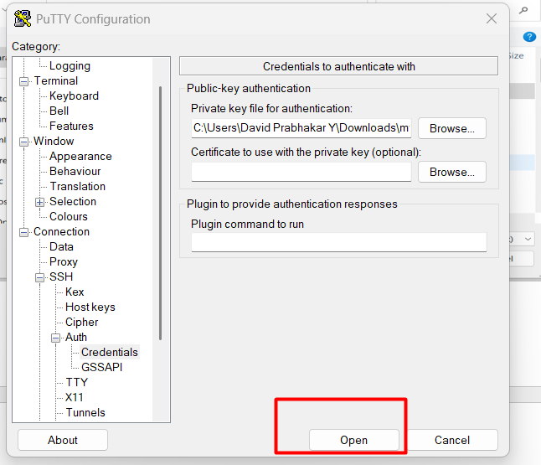

* Click on acceptance

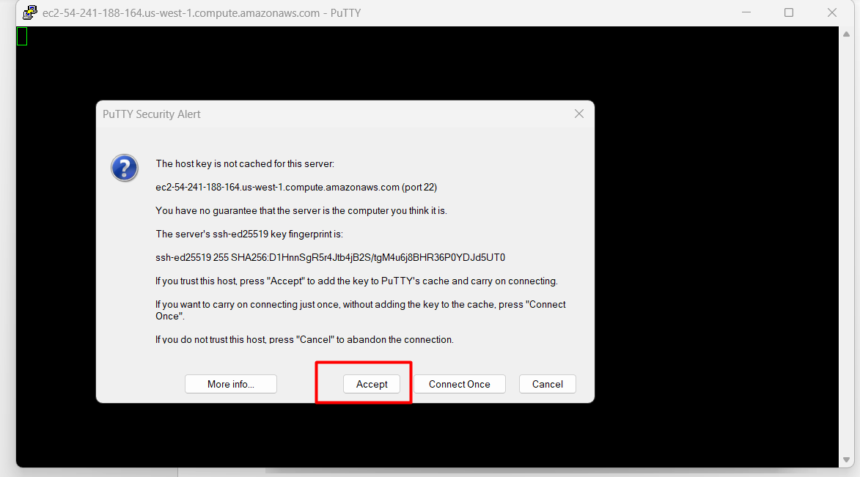

* Now you will connect to your server

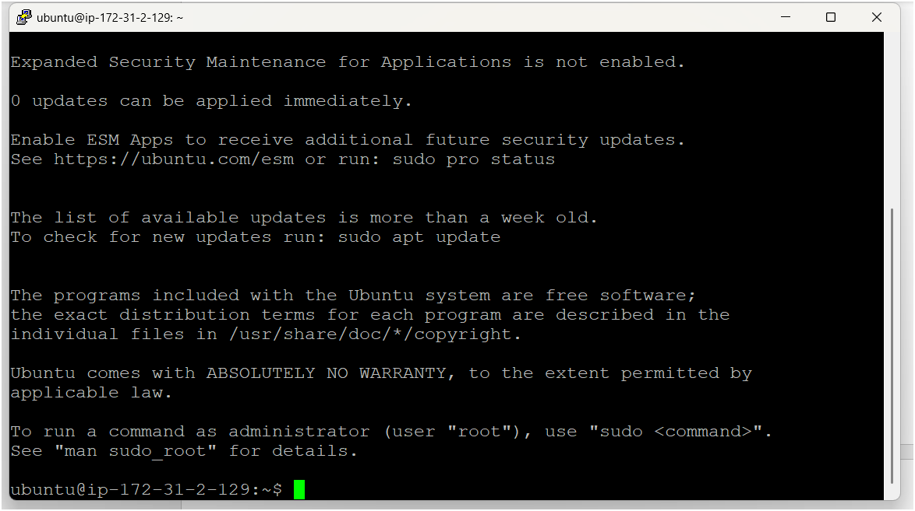

* After logged to server firstly you need to become as a root user

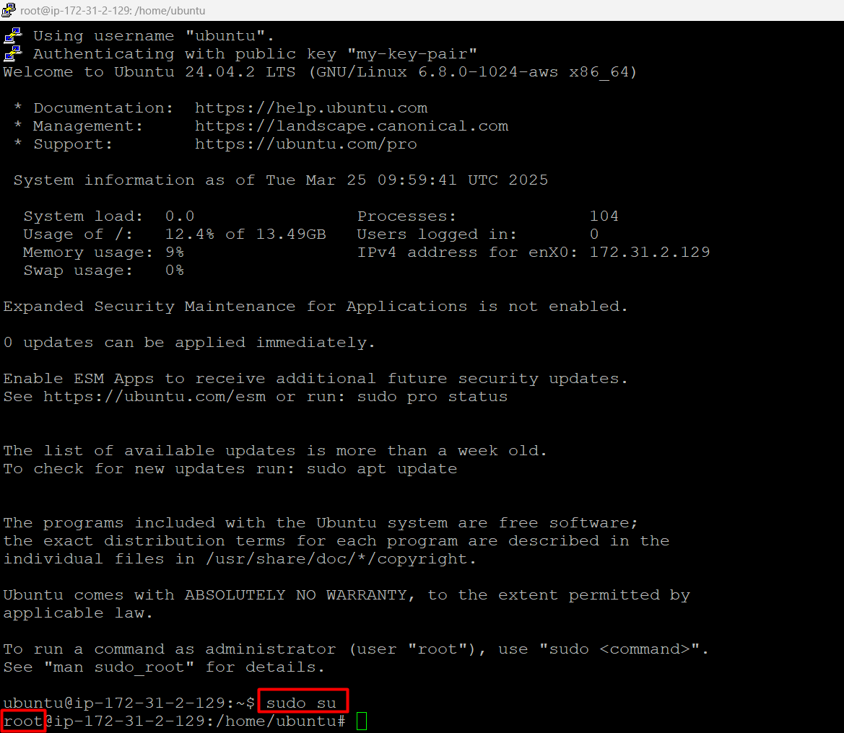

* Then update your server by using apt update -y

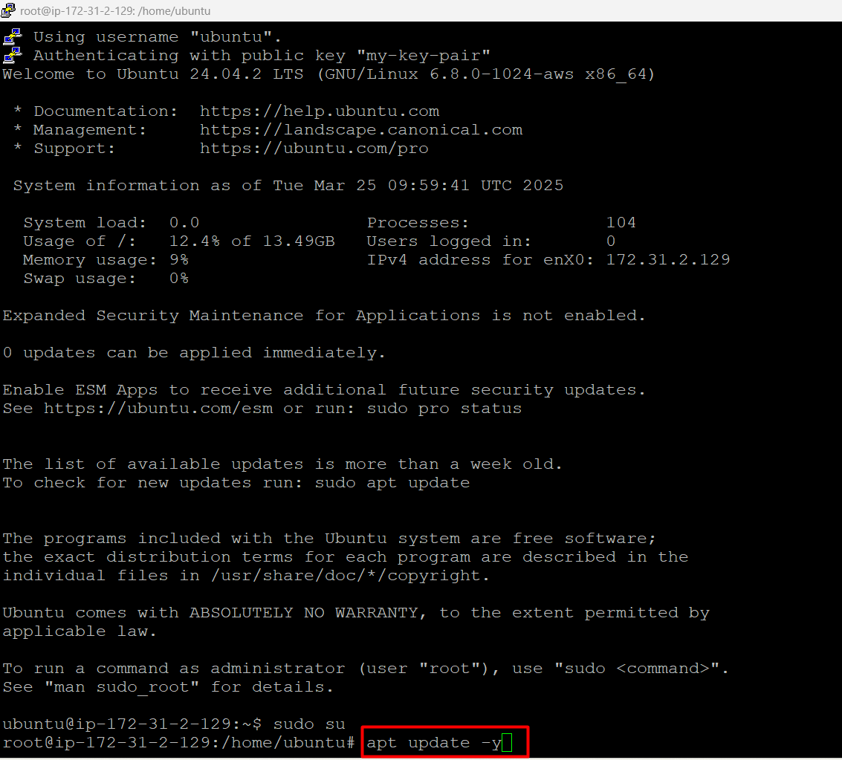

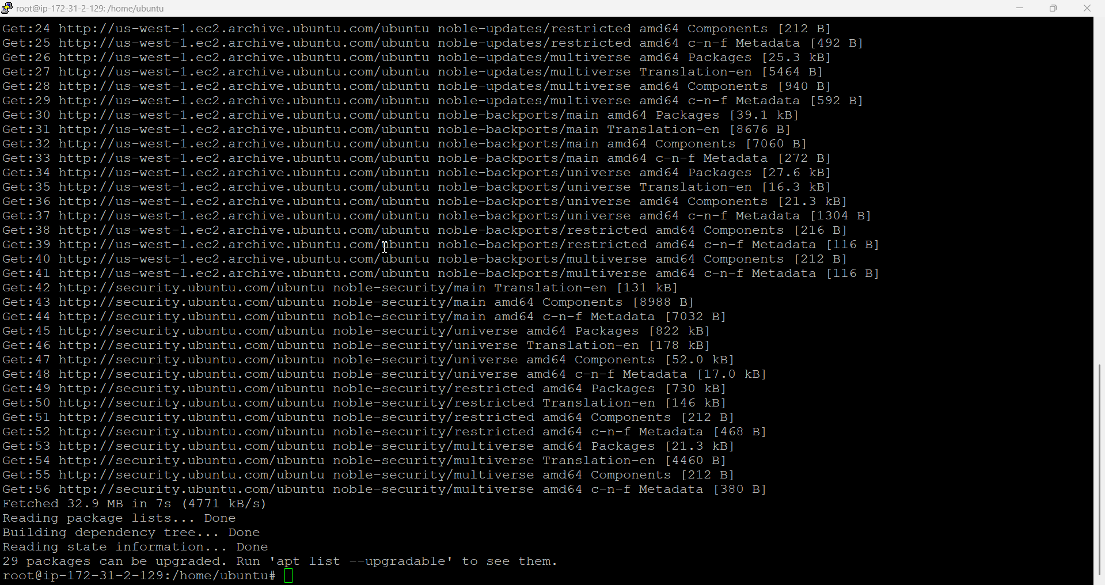

* Now we have to deploy one simple static hmtl login page on ec2 instance
* For that we need one web app for that we can use apache2 as web server
* How to install apache2 on ubuntu os/ec2 instance use following command

apt install apache2 -y

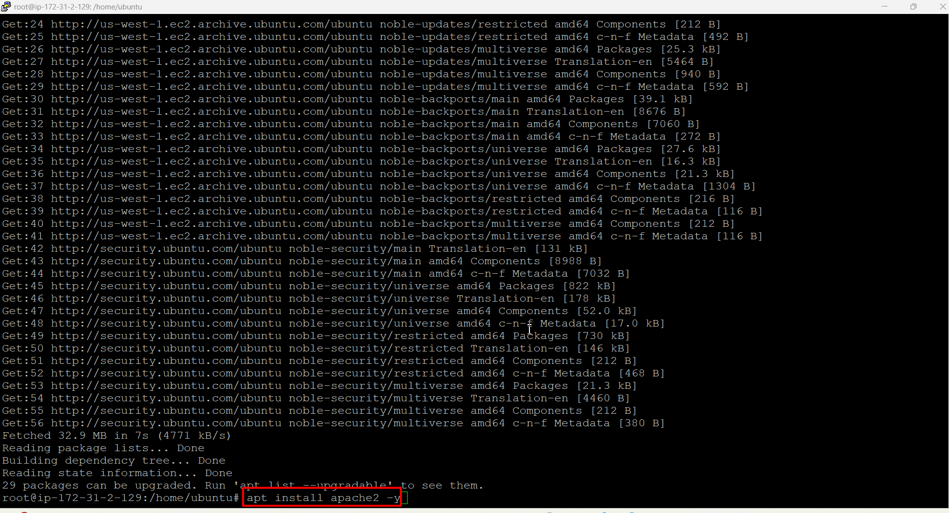

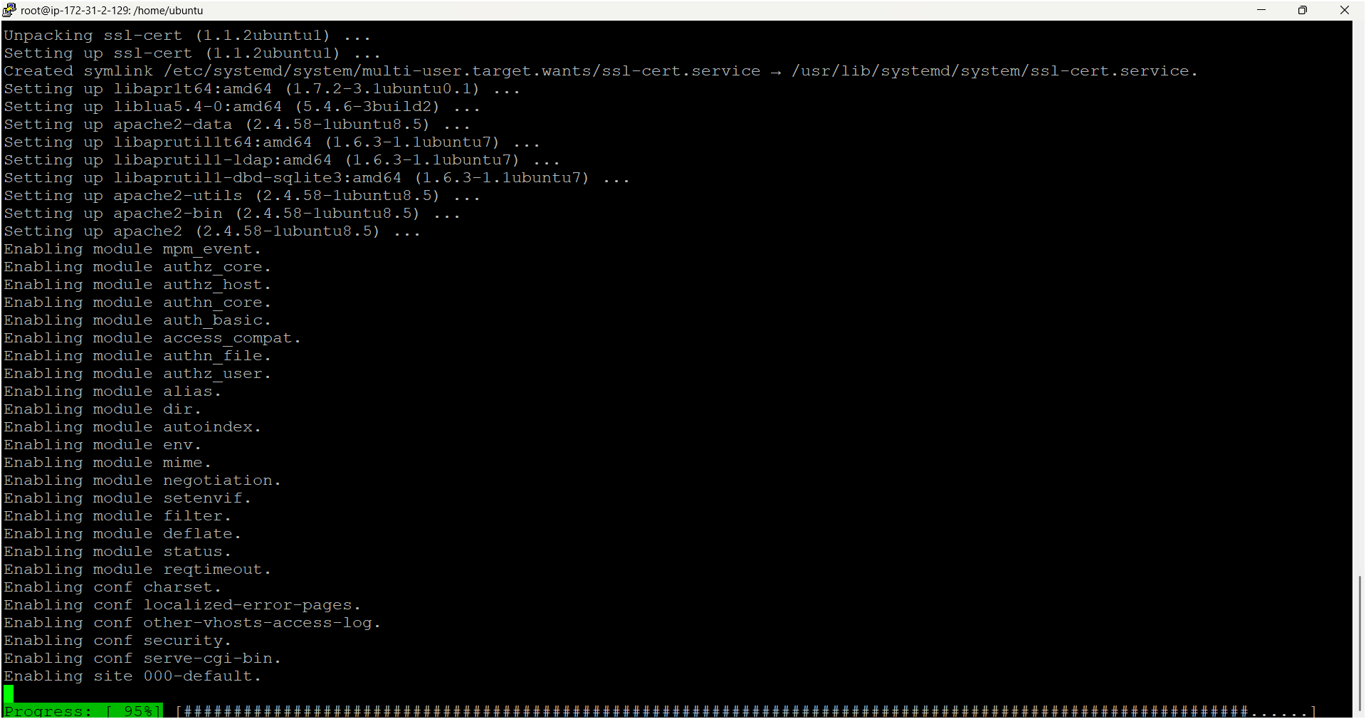

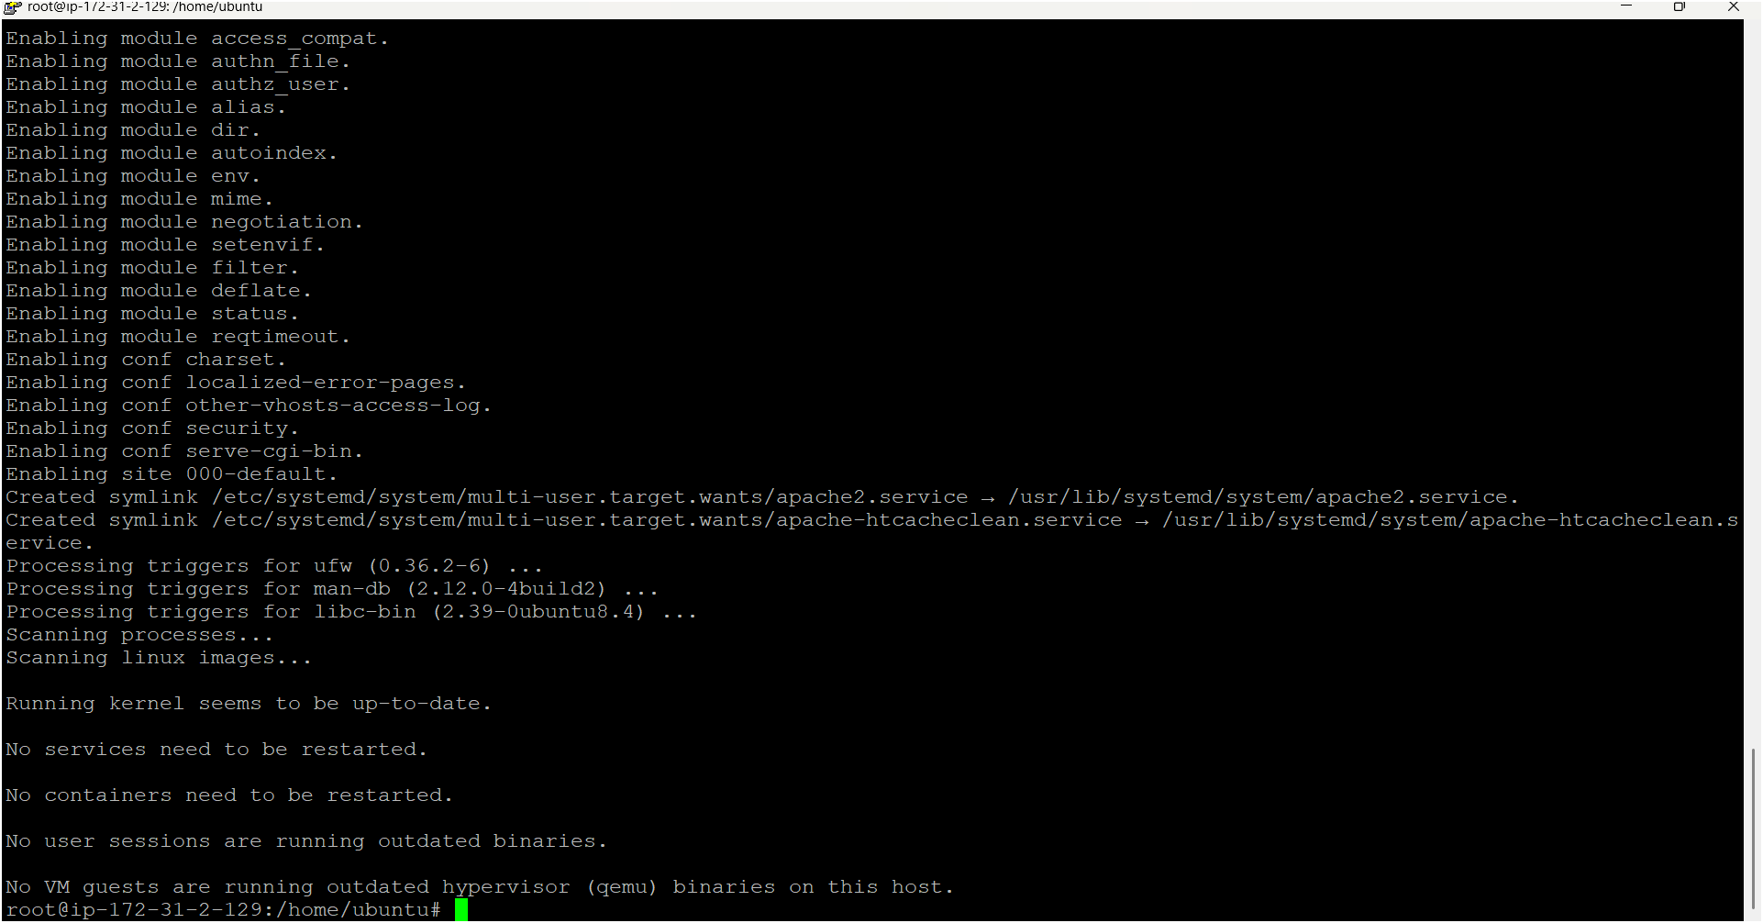

* Now we need to check apache2 status whether its installed or not by using below command

service apache2 status

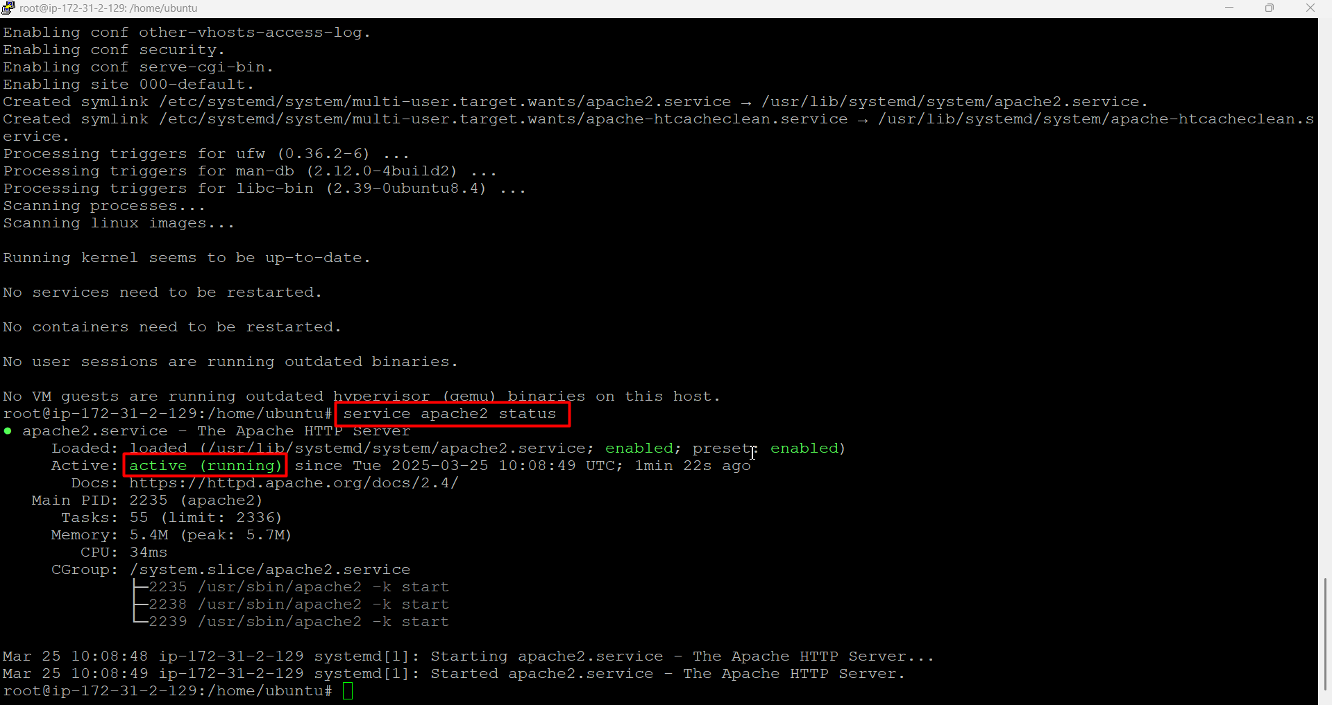

* For suppose apache2 is in inactive or failed manually you have to restart it using below command

service apache2 restart

* Now we have to go to apache2 root directory named /var/www/html using below command

cd /var/www/html

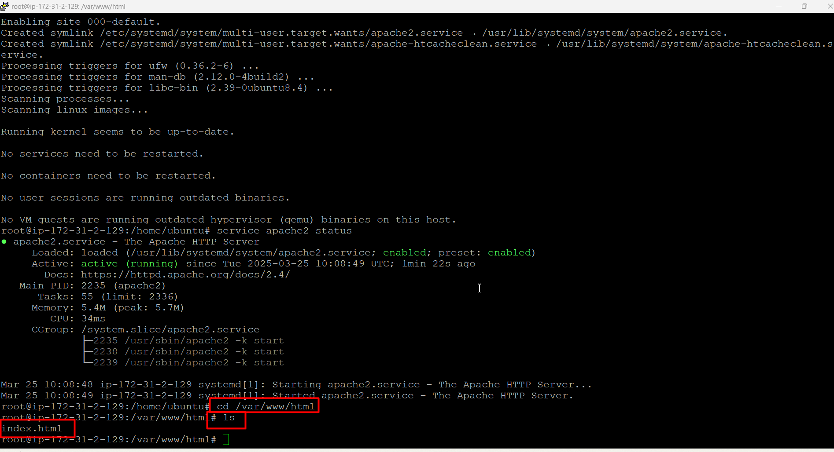

* Now we can deploy our html login page on apache2 web server
* Before there is default file named index.html delete it and create again as shown below image

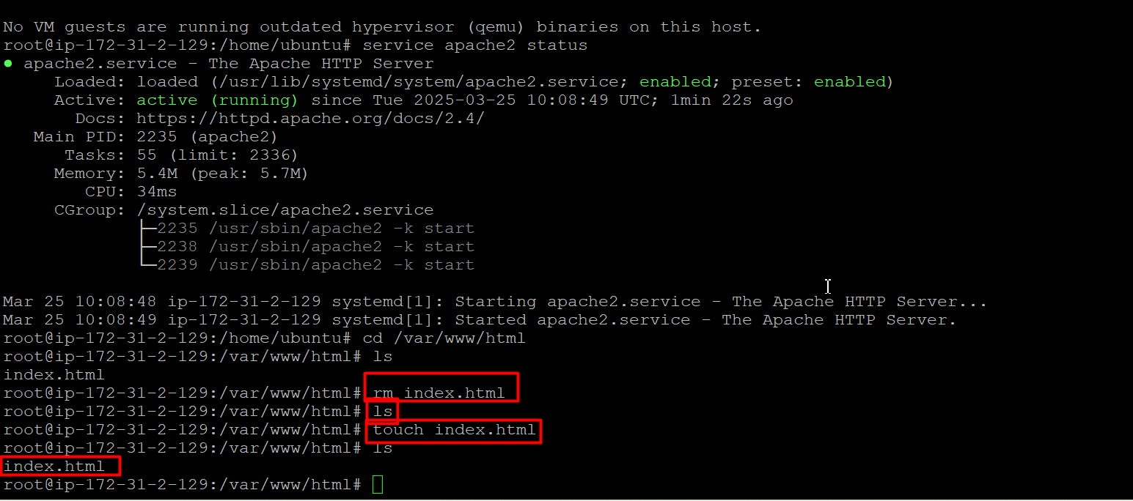

* Get code from w3 schools



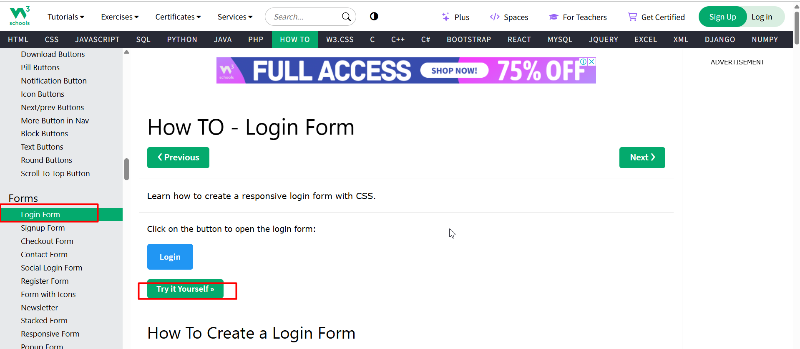

* Copy source code as below image

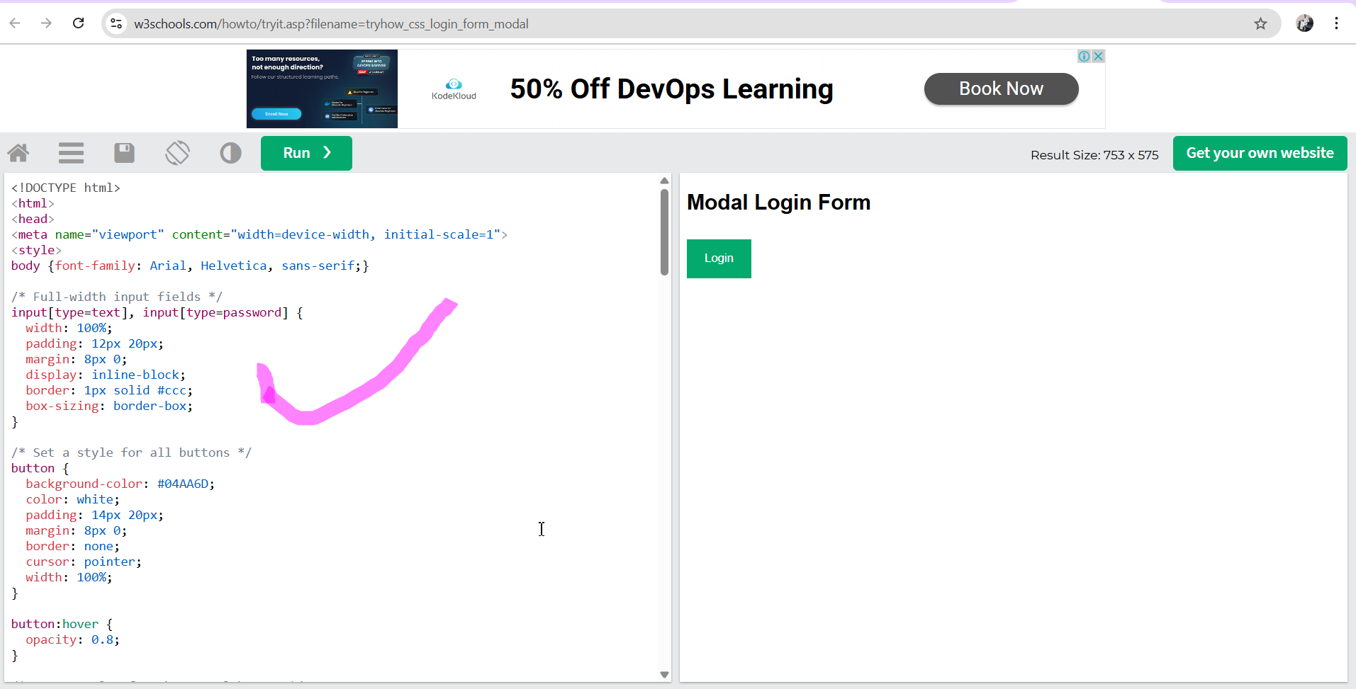

* After go to server open your index.html file as shown below image

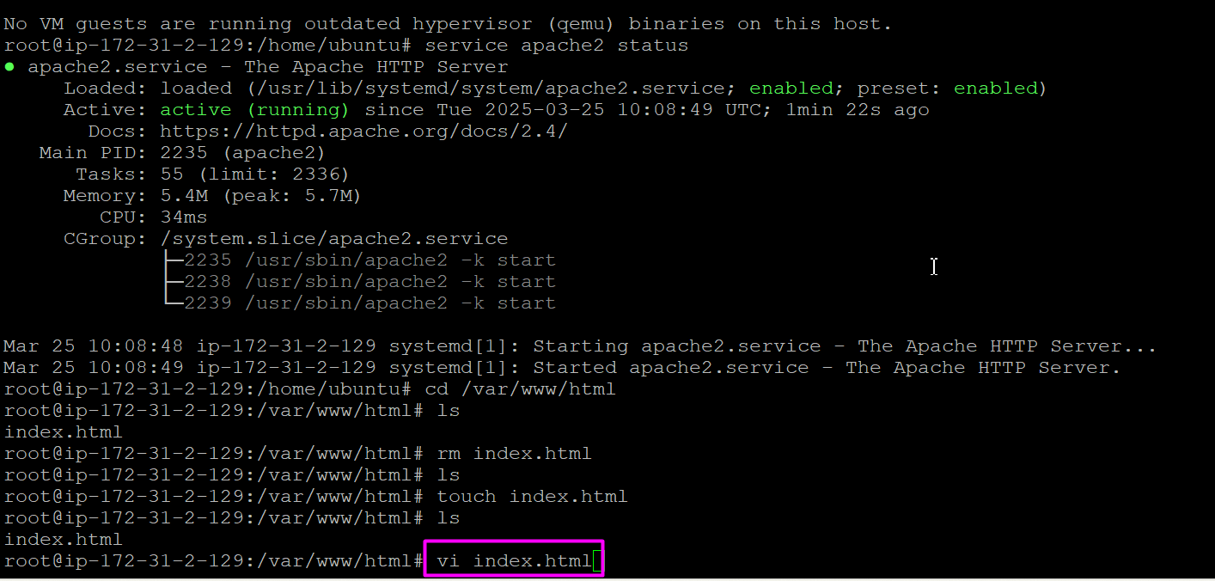

* It will open like this 👇👇



* Press “I” on your keyboard then paste your copied code inside the file

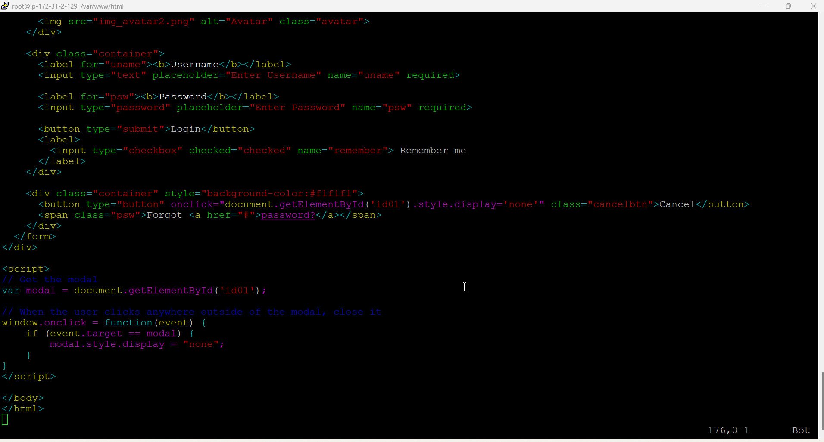

* Now save n close this file by using below commands on your keyboard press

Esp + : + wq (esp:wq)

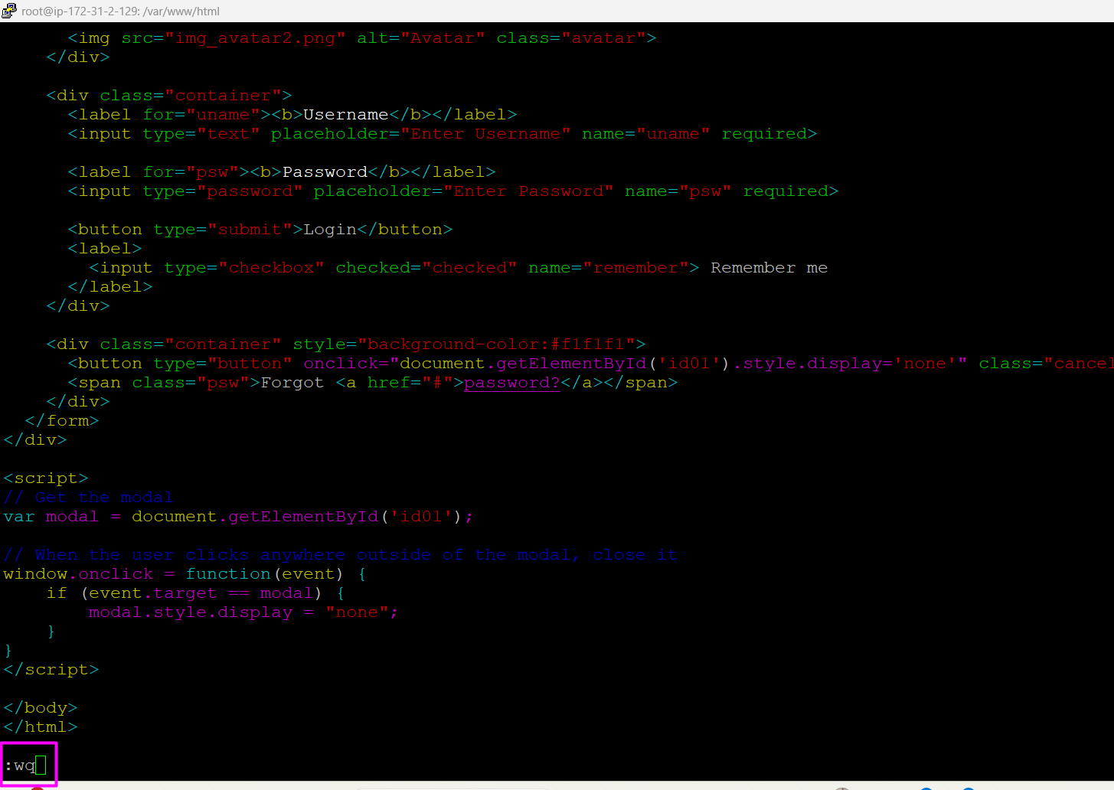

* Now restart your apache2 server

service apache2 restart

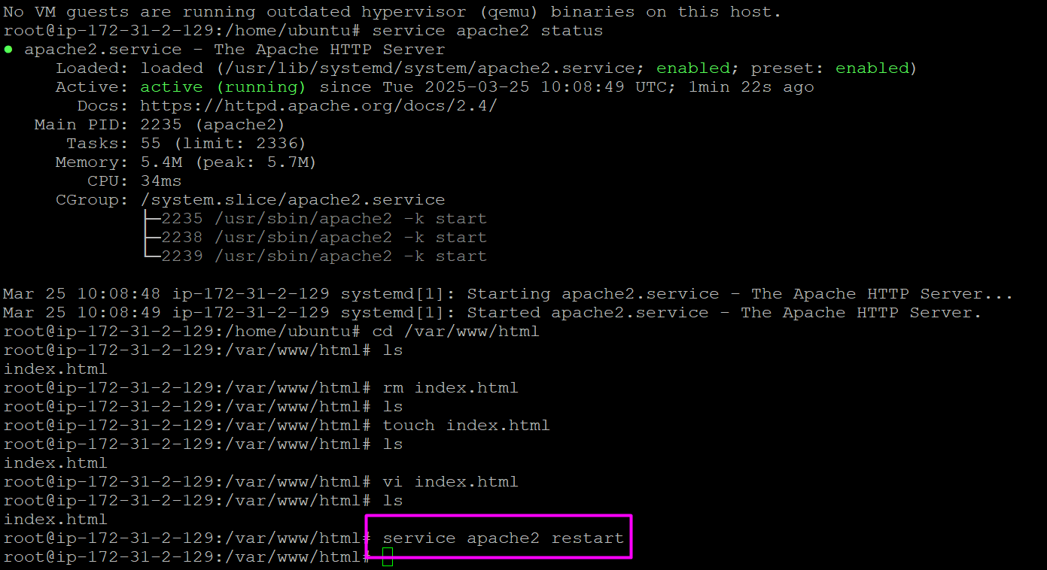

* Now access your html login page app by using your instance public ip add with port no 80 (apache2 web server will work on port no 80, before that you must enable port number on security group)

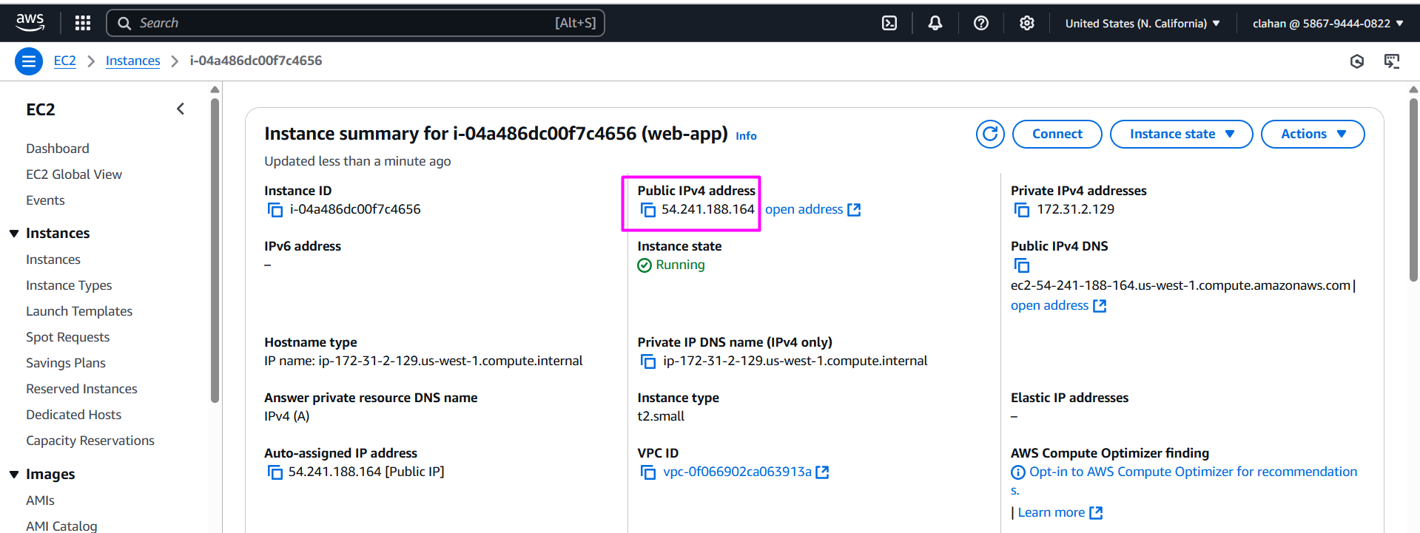

* Open browser paste ip address as shown the image 👇

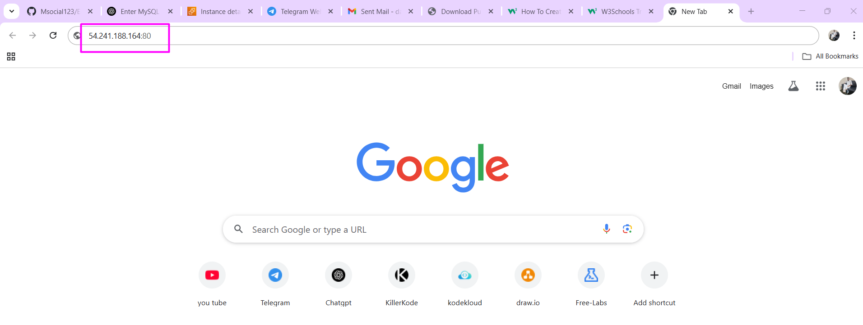

* Able to access html login page

